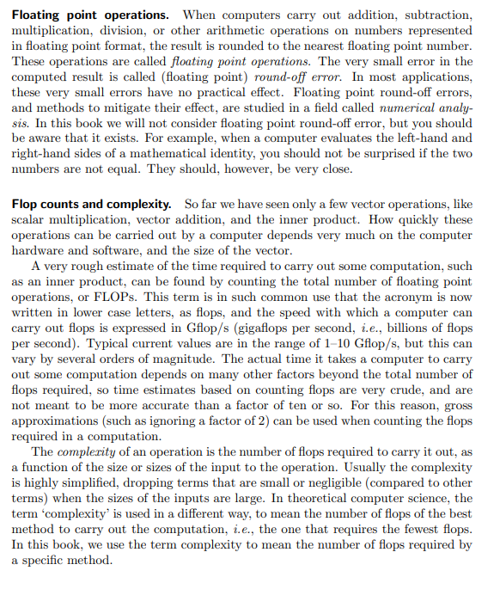
PG 23
When I was going through the book the place that stuck me was when floating point results in round – off errors which have no practical effect, then why cant we use integers or whole number in place of float.

